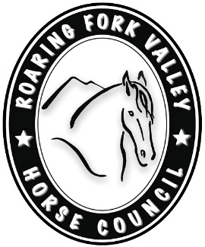

ROARING FORK VALLEY HORSE COUNCIL
P O Box 127
Snowmass, CO 81654
www.rfvhorsecouncil.org
www.facebook.com/keephorsesontrails/

(Add Date Here)
(Type Text Here)

RFVHC BOARD OF DIRECTORS
President/Marketing Promotion Chair – Karin Reid Offield Vice President & Events Chair – Rheta Fulton
Secretary & Trails Chair – Susan Cuseo Treasurer – Alexandra Anwyl-Davies Western Heritage Chairman – Marty Schlumberger Communications Chair – Holly McLain Education & Equine Health Chairman – Sam Johnson DVM Equine Community Outreach – Chuck Maker DVM Social Media & Trails – Taylor van Zyl
Fundraising – Shannon Weeks Member-at-large – Arnie Mordkin

